

Safer Communication

Dynamic Routing

Resultant Product Has Short Life

Social Control

Sensor Network

Analystics

Seperate Bio- degradable and

Non- Biodegradable

IBM Cloud

LoRa

Trash Collector

Eco - friendly

Dustbins have limited Memory

Empathy Map Canvas

Gain insight and understanding on solving customer problems.

1

Build empathy and keep your focus on the user by putting yourself in their shoes.

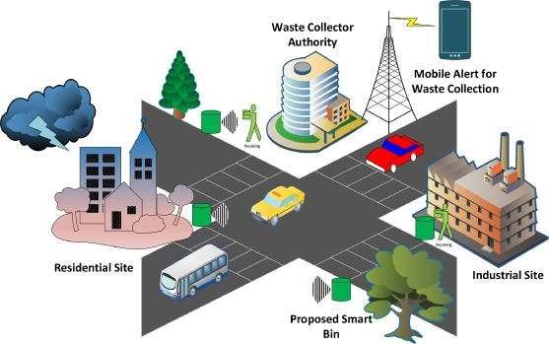

Recycle, Reuse, Reduce

Proper Disposal

Waste Transfer Facilities

Reduce Overflow

Garbage Level Monitored by WebApp

Conserve Natural Resources

Track The Location With Real Time Data

Fixed routine for waste collection

Still Under Development

Excess Network Trust

Improve Cleanliness

Cost Deduction